Whoami ---- displays the current user account
ls – list all the files and directories in the current directory
ls -ltr - is a Linux command used to list files in a directory with detailed information, sorted by time.
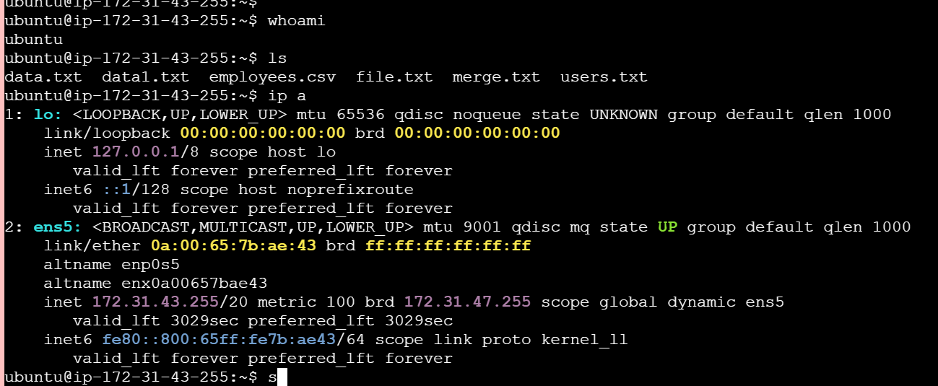
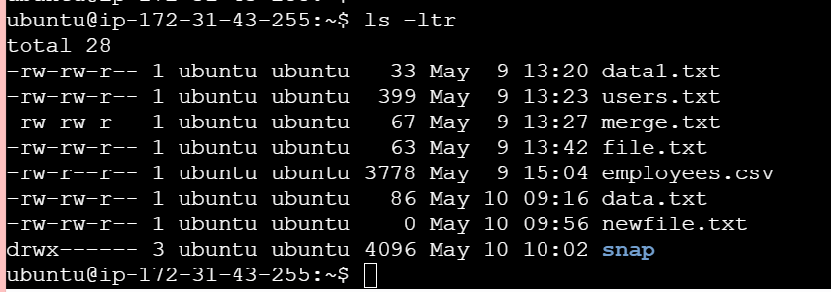
ip a --- is a Linux networking command used to display IP address configuration of all network interfaces.
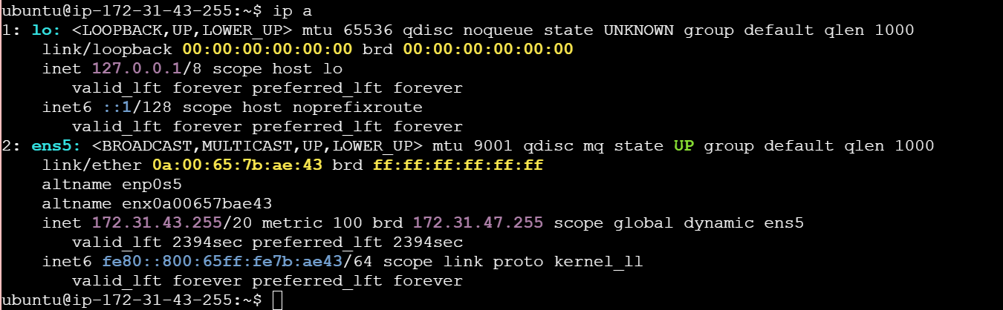

Cat - Reads the contents of text files and displays it.
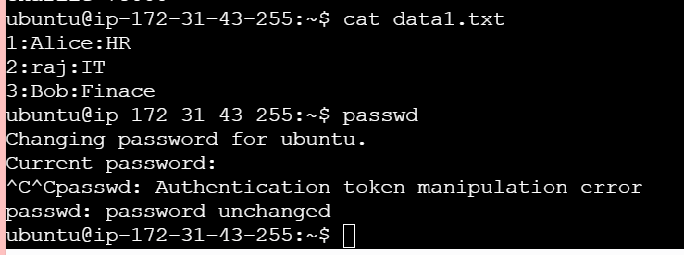
passwd – Used to change the password of the user account
touch – is used to create a file with 0 size, Creates empty files, mainly useful to test write ability
pwd - print working directory, shows which directory I am in.
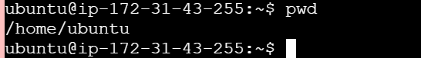
Man command – it is used to provide the manual of a particular command
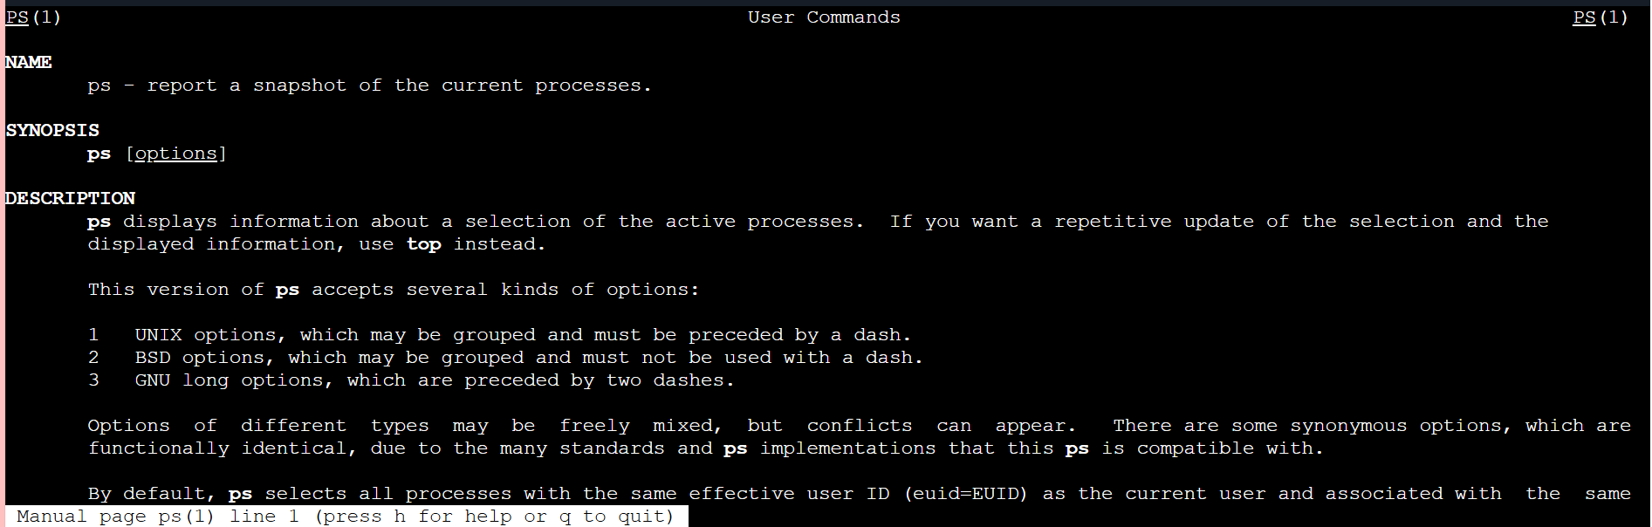
apropos - Searches commands related to a specific task based on description
(equivalent to man -k).
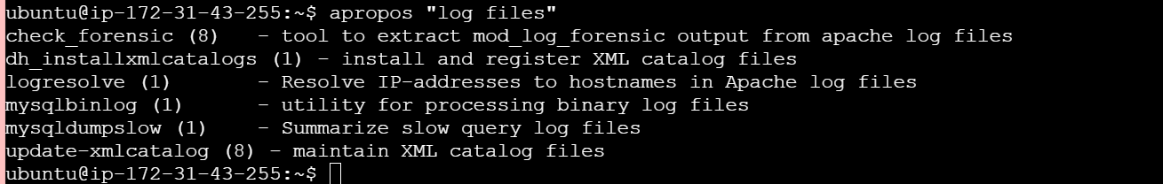
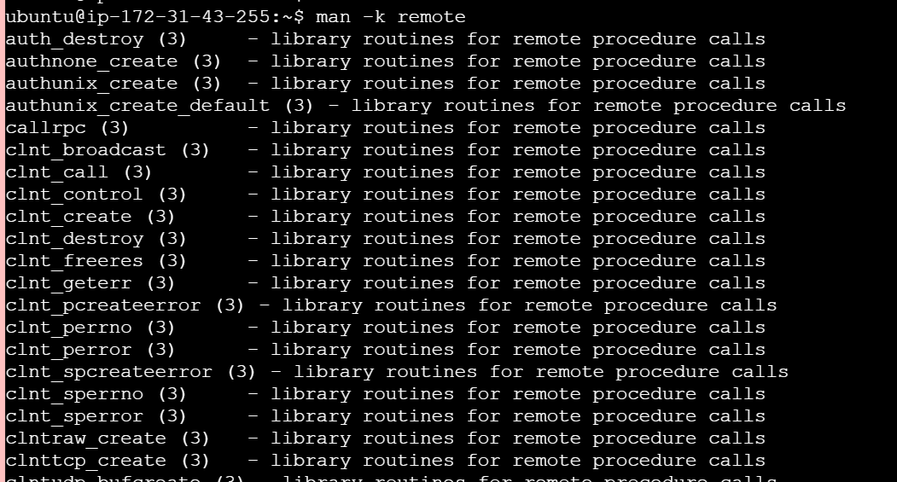
tldr – (too long, didn’t read) – shows command line examples, a simplified version of man
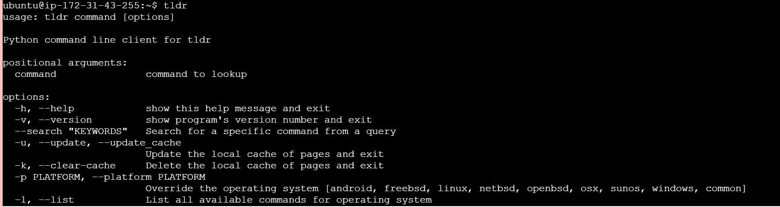
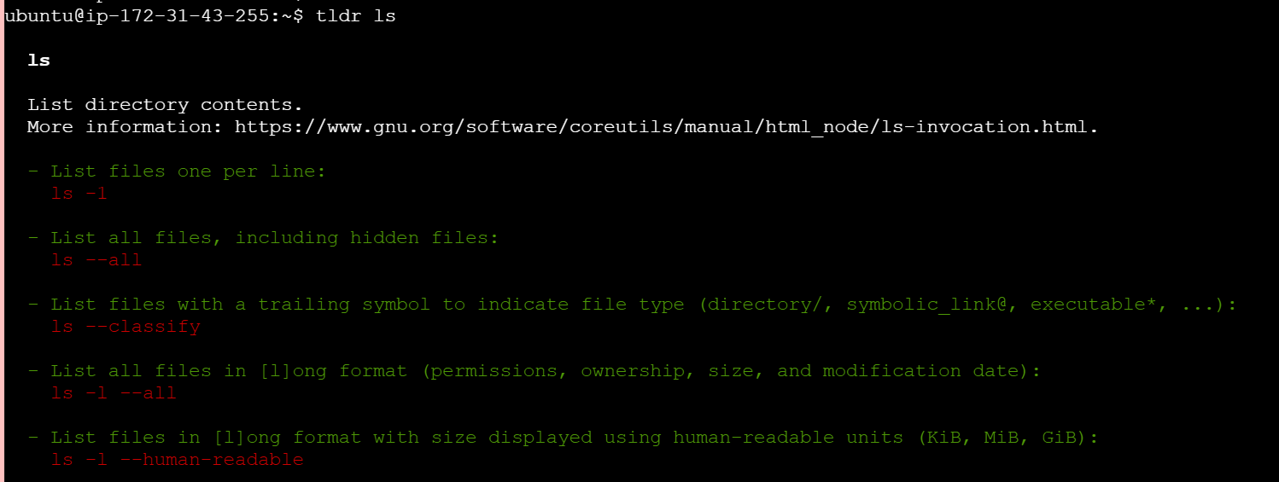
Essential File Management Tools Commands
cp source.txt destination.txt --- Copies files from one location to another. This command duplicates files.
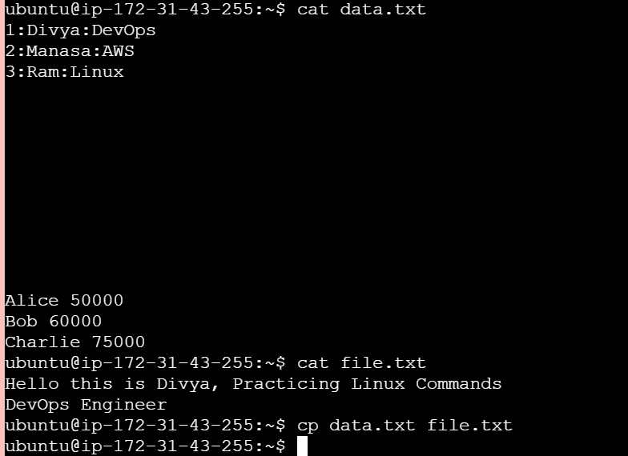
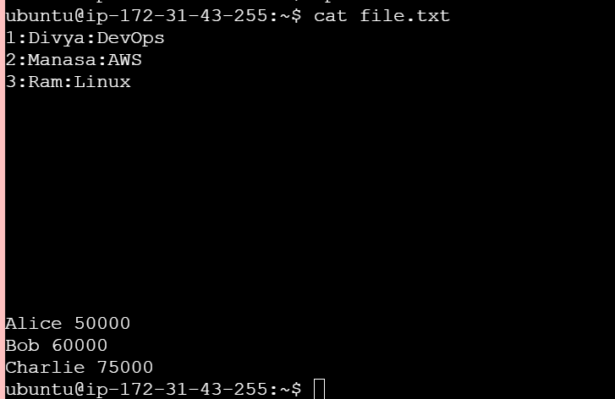
mkdir – creates ditrectory --- mkdir directory_name

rmdir – deletes directory --- rmdir directory_name
Removes a directory, but only if it's empty. This command is used for deleting empty folders.
mv --- It is used to move files/directories from one location to another or rename files/directories.
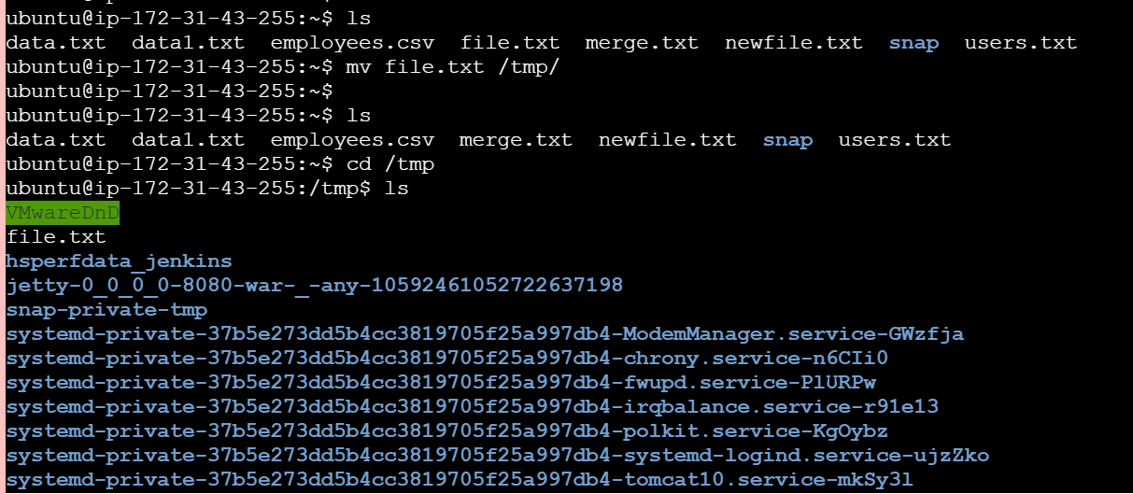
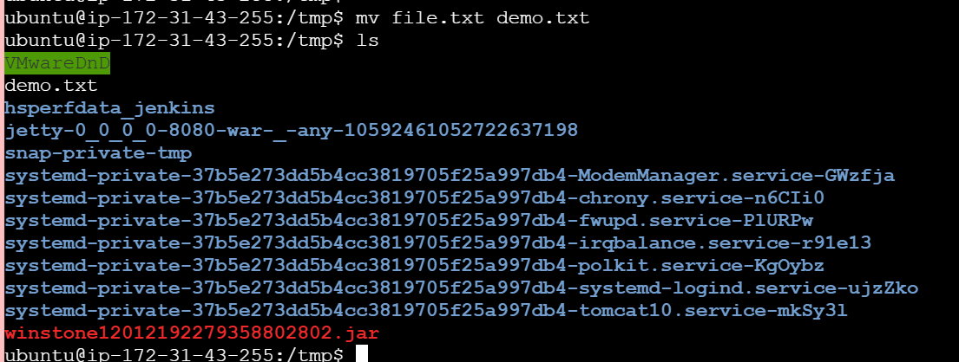
rm filename - It is used to delete files and directories in Linux
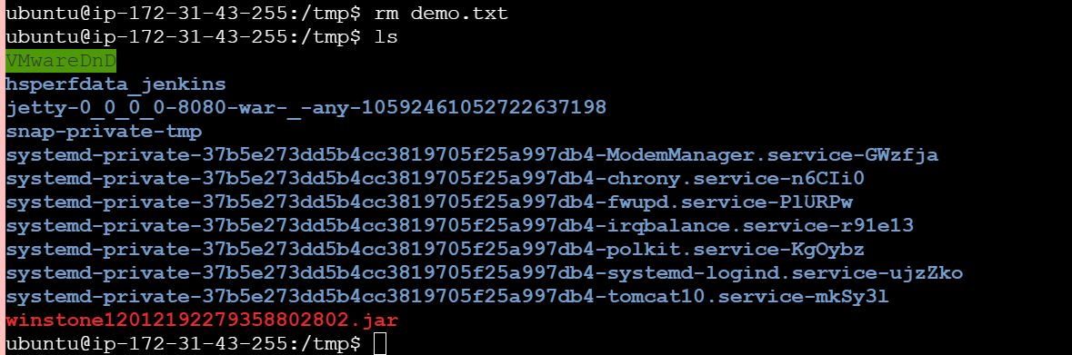
Advanced File Management Tools Commands
ln (Link Command)
Purpose: Creates links between files (hard link or symbolic link)
Syntax:
ln source_file link_name
ln -s source_file symbolic_link
Example:
ln -s file1.txt link1.txt
Description:
ln → creates hard link
ln -s → creates symbolic (soft) link
Symbolic link = shortcut to original file
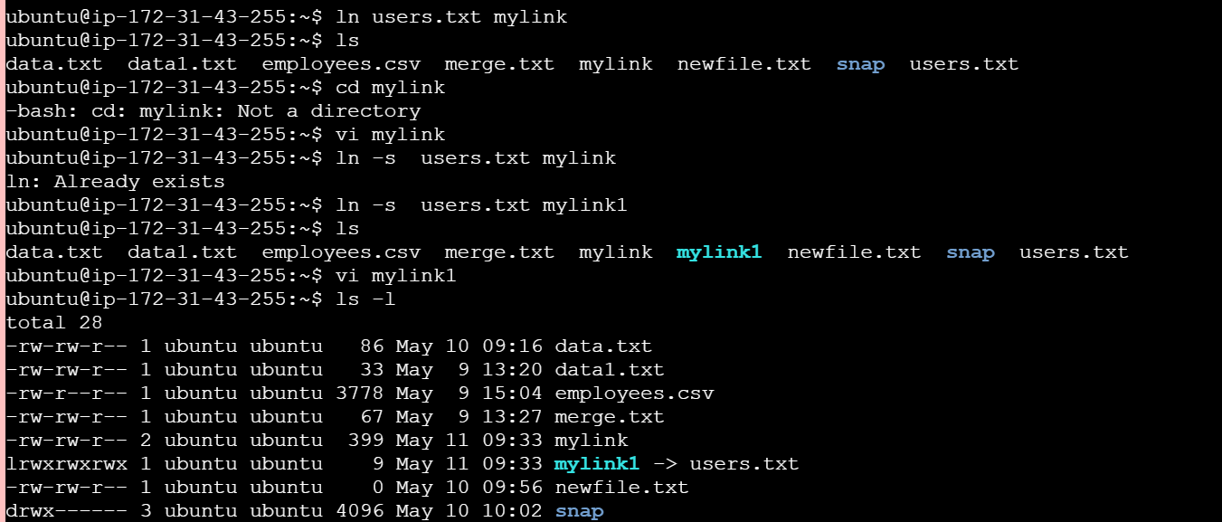
find (Search files by conditions)
Purpose: Searches files/directories in real-time based on conditions
Syntax:
find <path> -name "pattern"
Example:
find /home -name "*.txt"
Description: Searches files by name, size, type, permissions, etc.
Very powerful and real-time command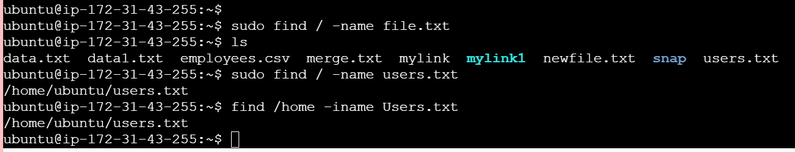
locate (Fast file search)
Purpose: Quickly finds files using pre-built database
Example:
locate filename.txt
Important: updatedb
Description:
- Much faster than find
- Uses database instead of scanning disk
- Needs periodic update using updatedb
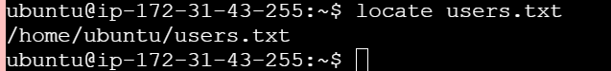
which (Find executable path)
Purpose: Shows full path of command/executable
Example:
which python
Output example:
/usr/bin/python
Description:
Shows where command is installed
Works only for executables in $PATH
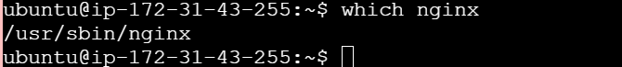
tar (Archiving tool)
Purpose: Combines multiple files into one archive
Create archive:
tar -cvf archive.tar folder/
Extract archive:
tar -xvf archive.tar
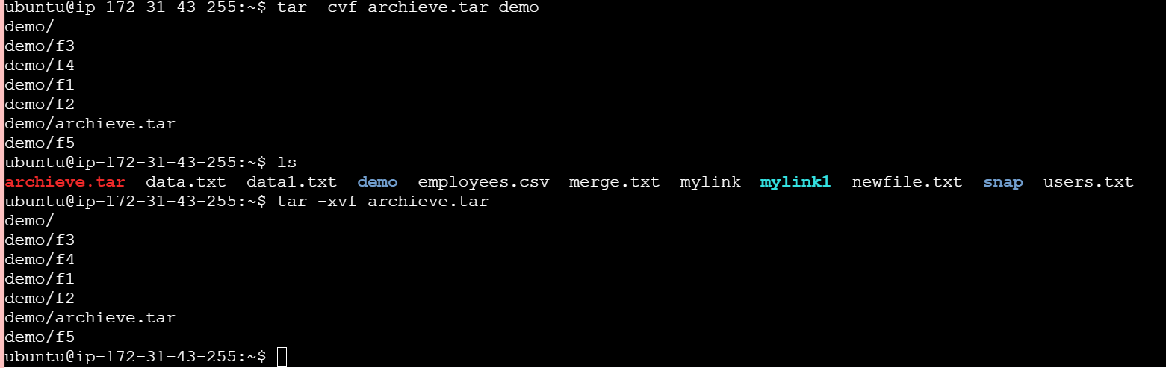
gzip
bzip2
xz
zip
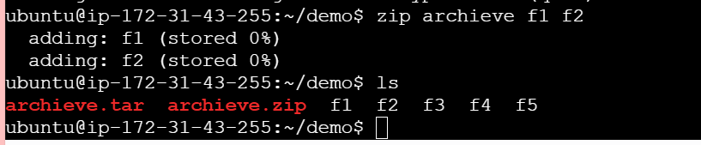
file command
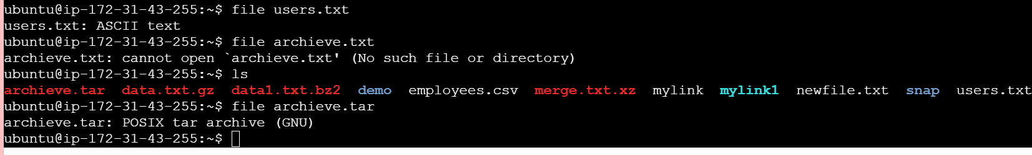
Mount
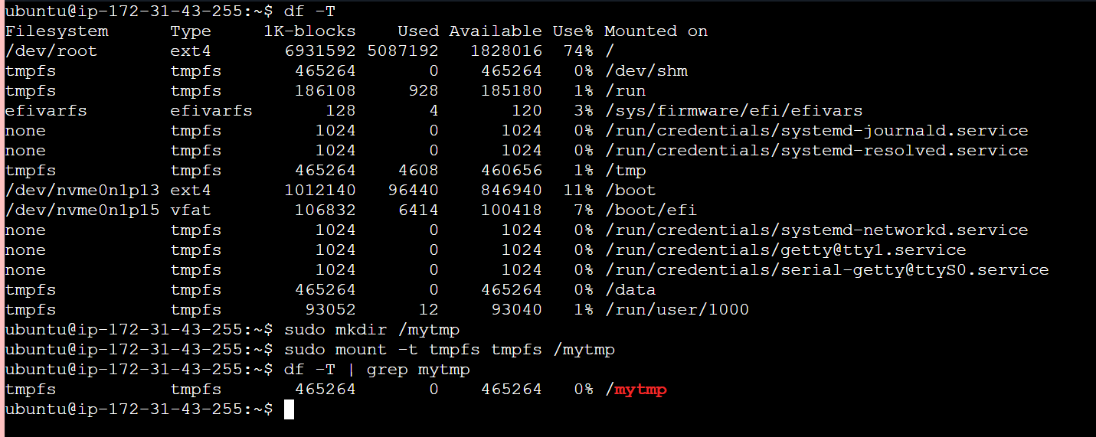
df command
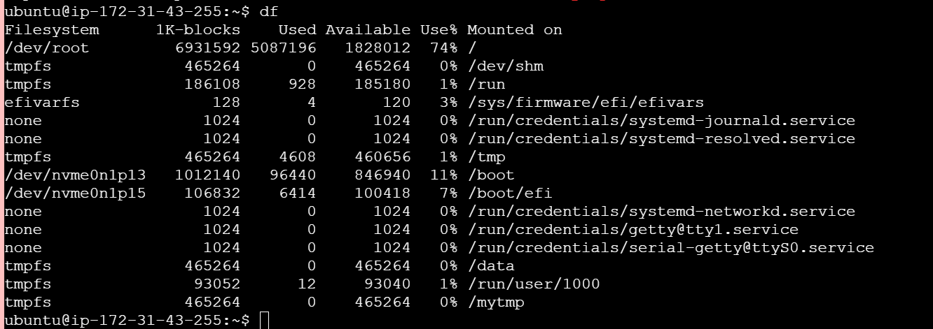
findmnt Command
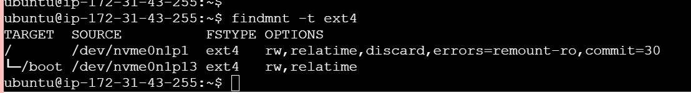
lsblk (List block devices)
Purpose: Lists all storage devices and partitions
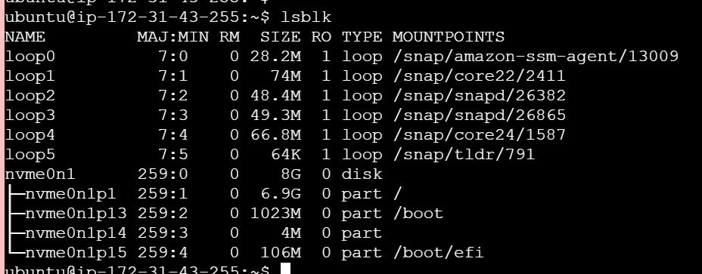
Working with Text Files Commands
Nano Command ---
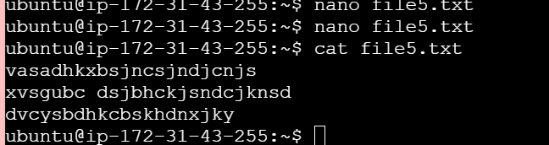
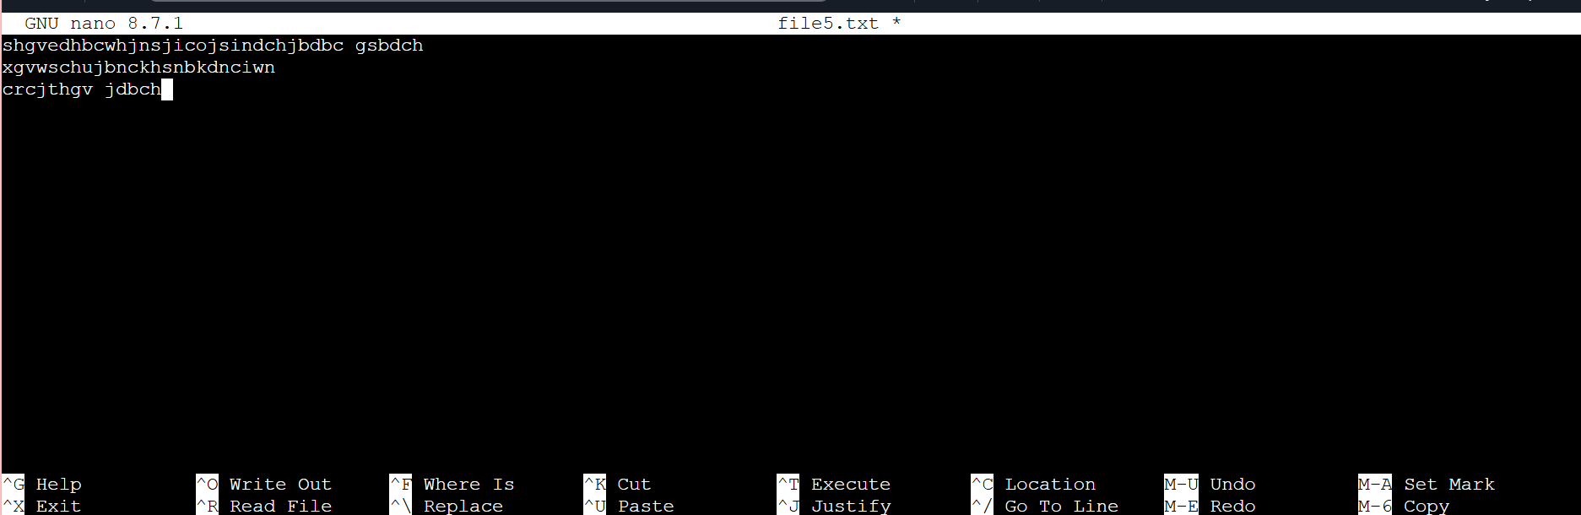
VI Command

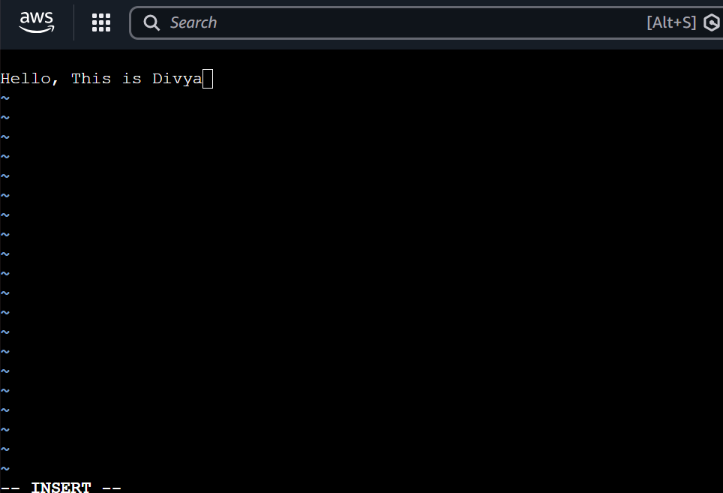
vimtutor command
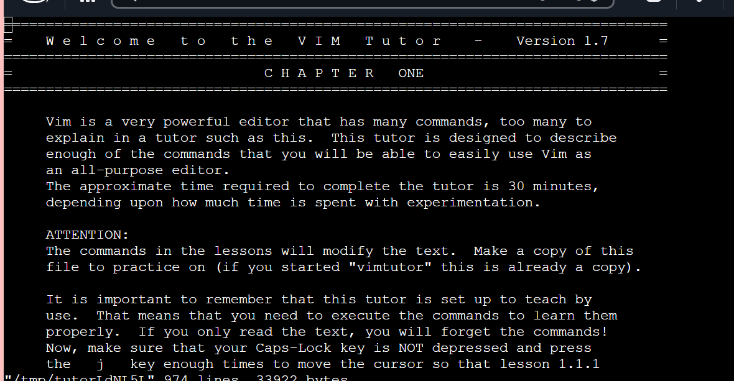

VIM Command
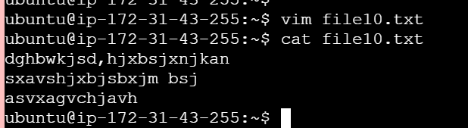
More Command -
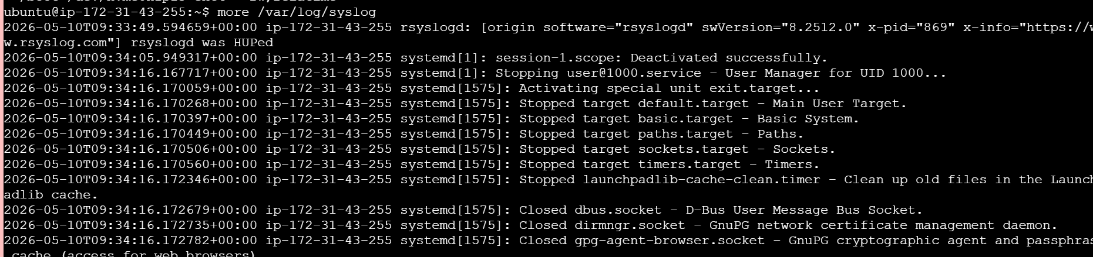
Less Command
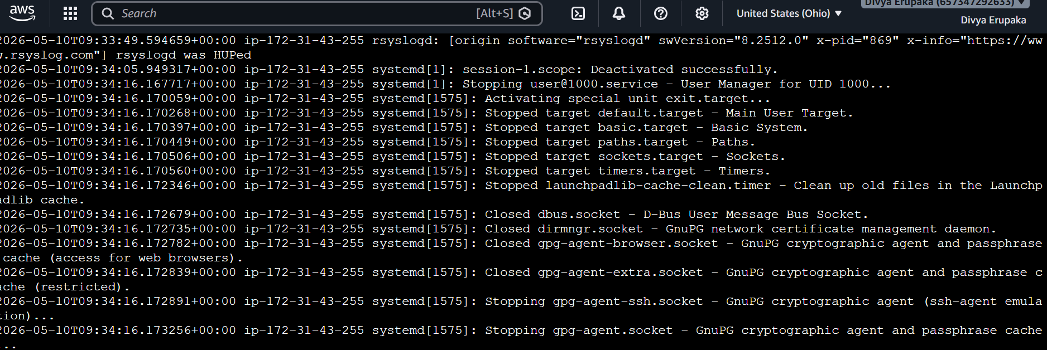
Head Command
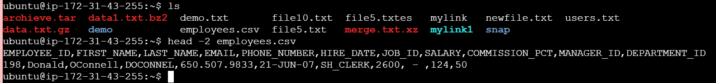
Tail Command
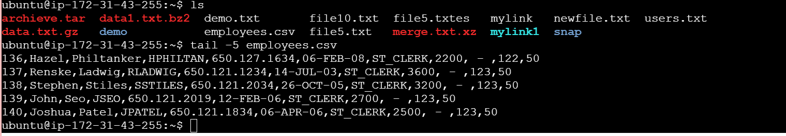
Cat Command ----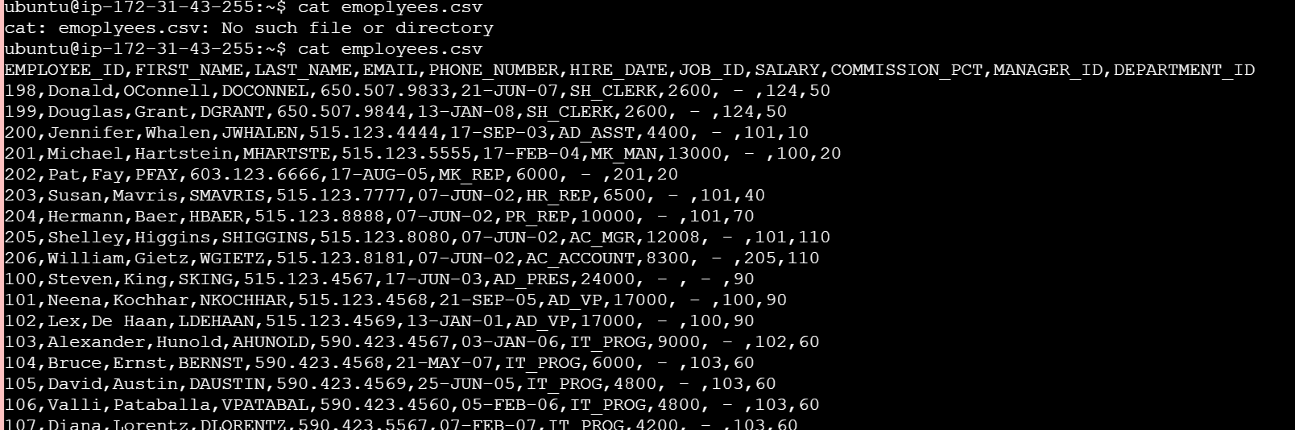
Cat -A command
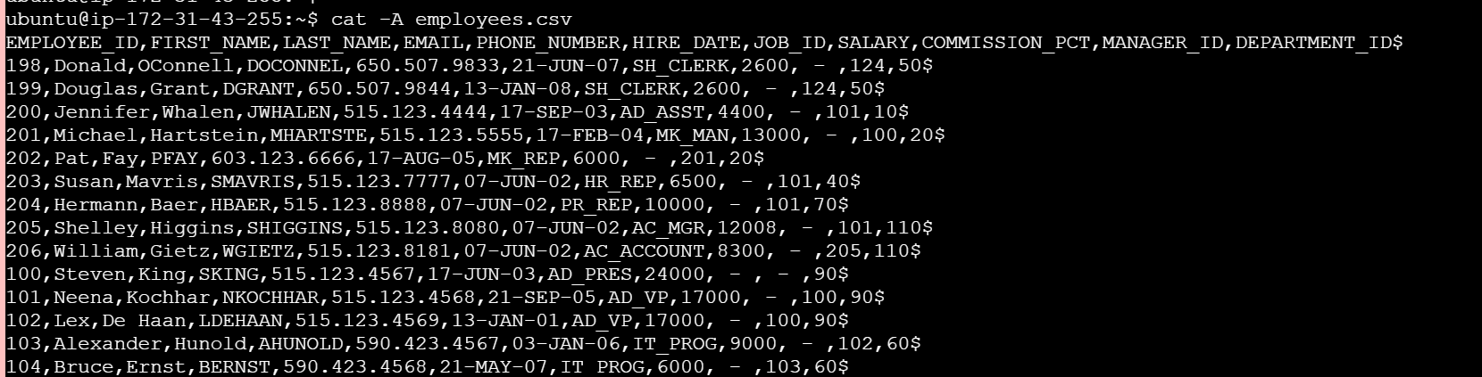
tac filename
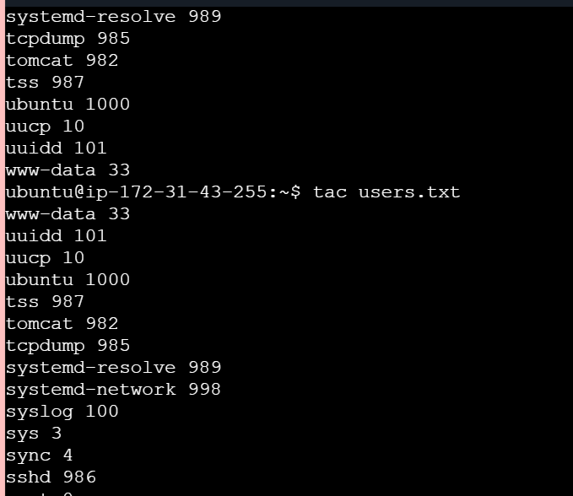
Grep Command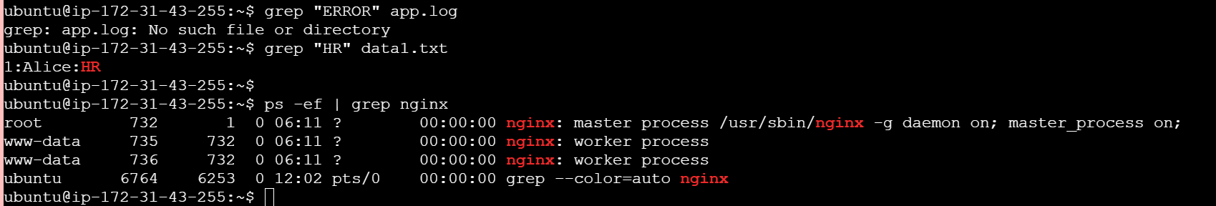
Advanced Text File Processing Commands
awk command
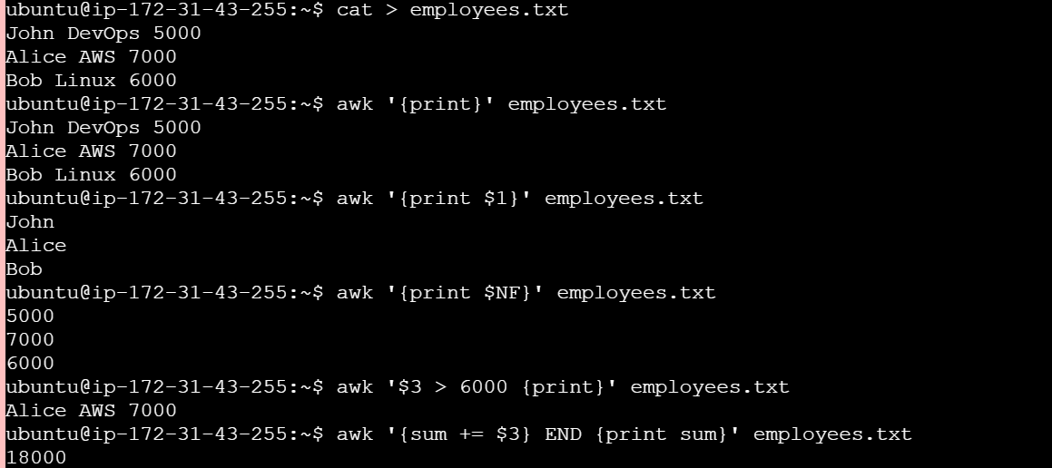
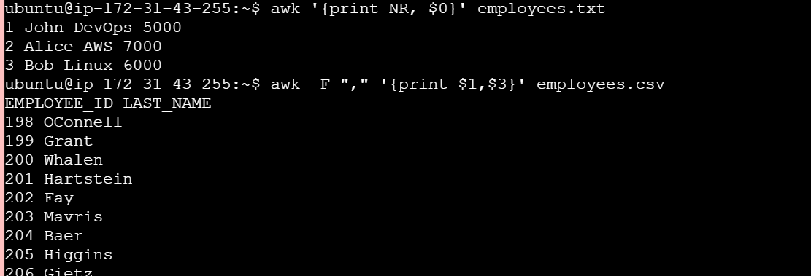
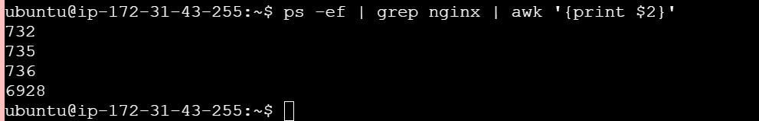
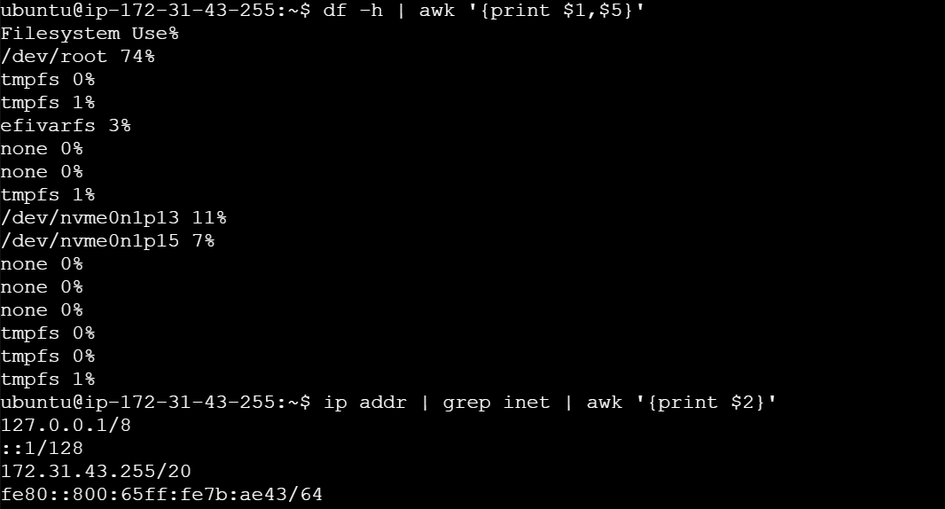
sed Command
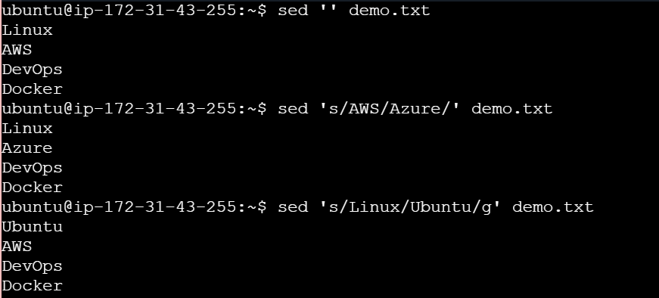
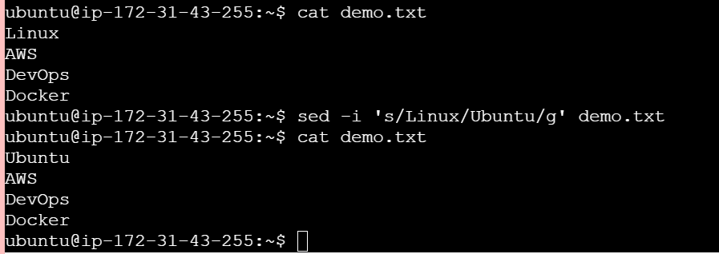
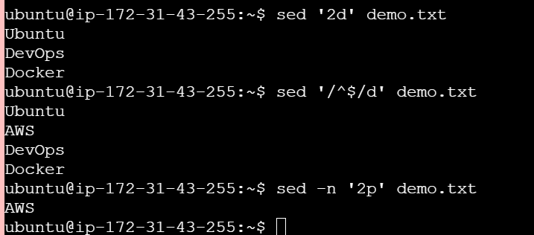
tr command
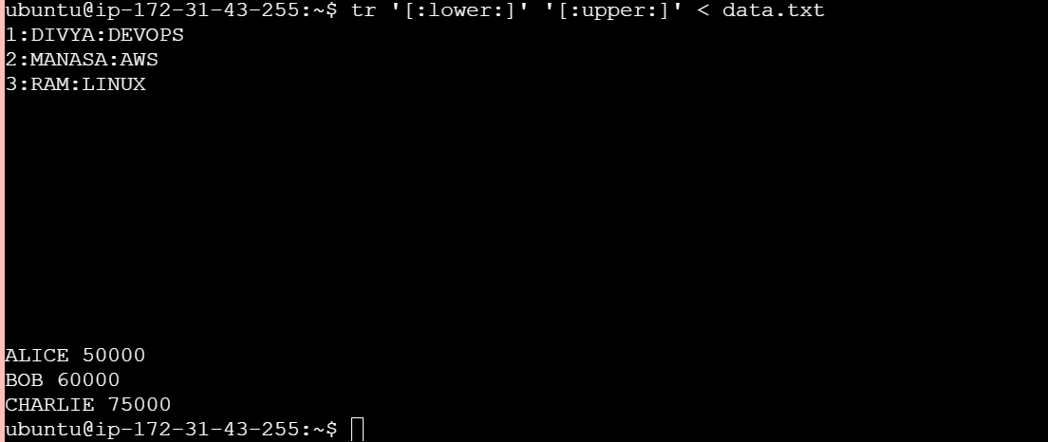
cut Command
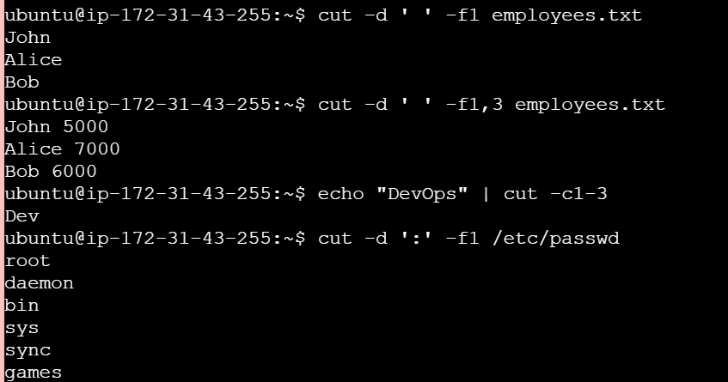
Sort Command
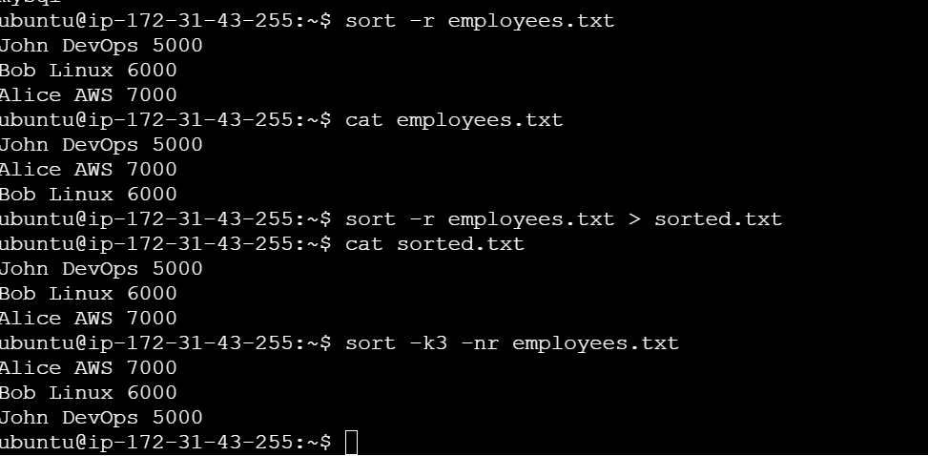
Connecting to Server Commands
su Command
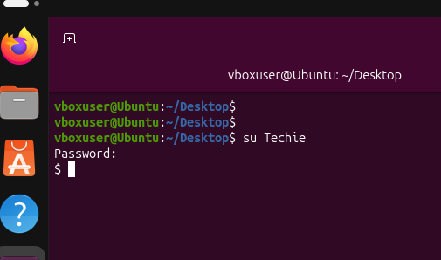
Sudo command
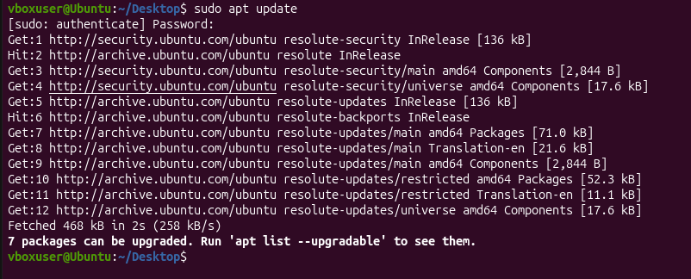
ssh ubuuntu@publicip
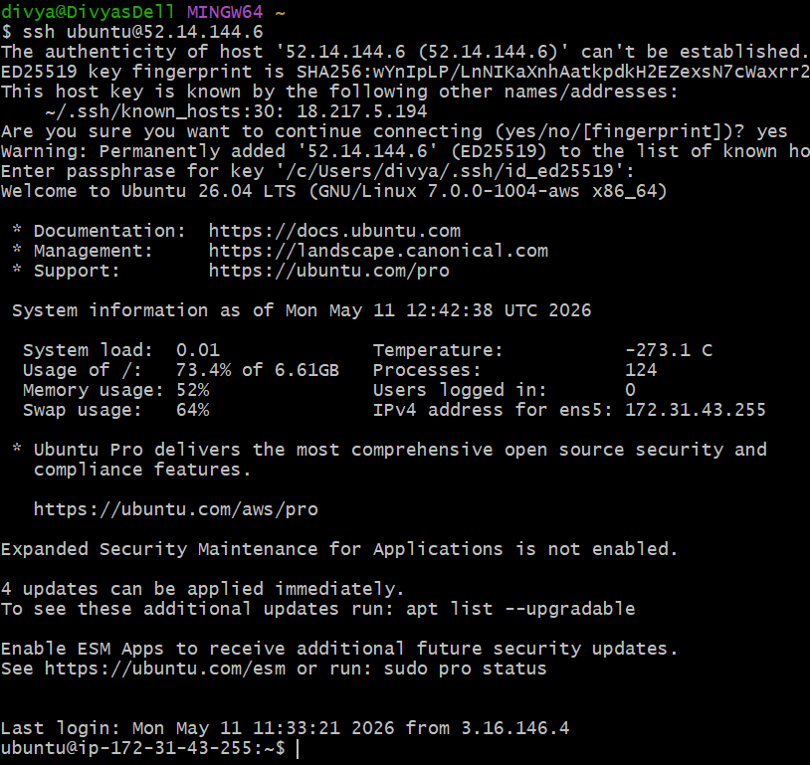
scp command
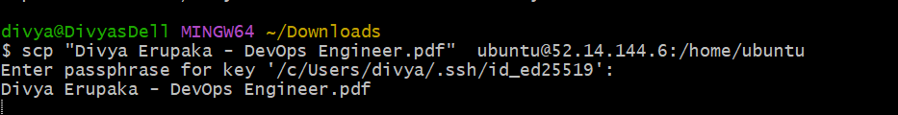

Reading Log Files Commands
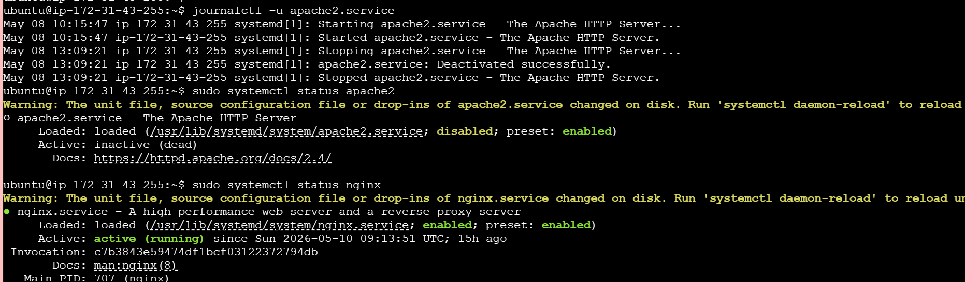
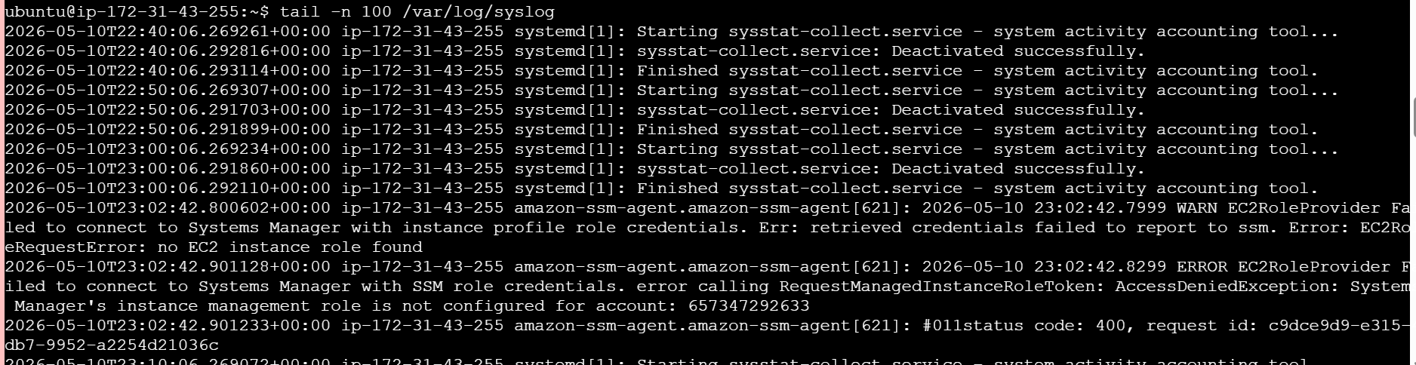
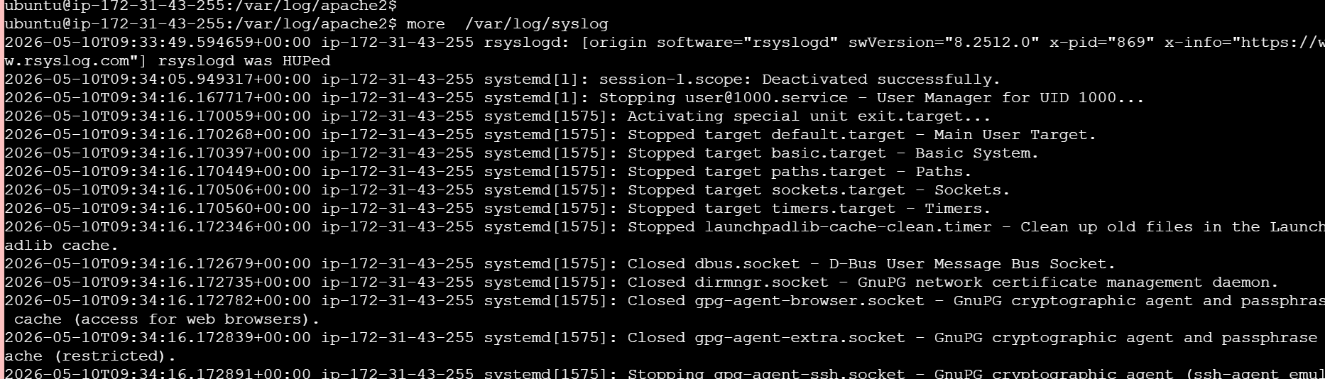
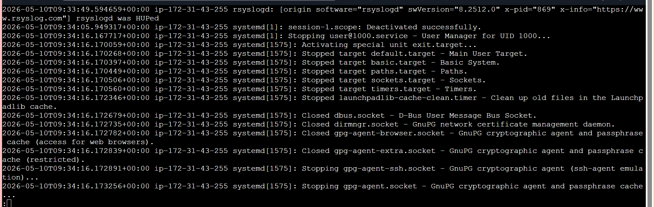
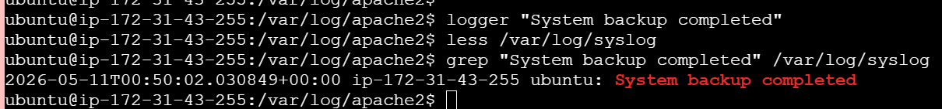
Scheduling tasks Commands
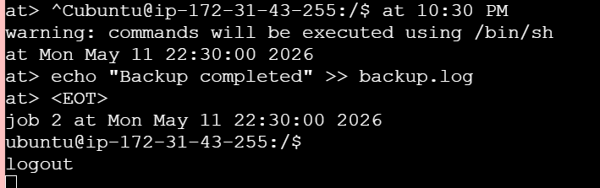
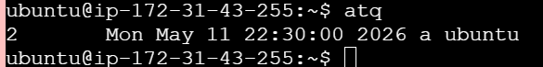
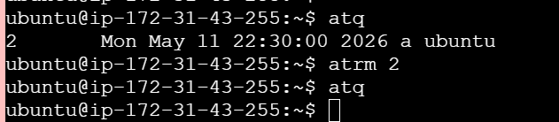
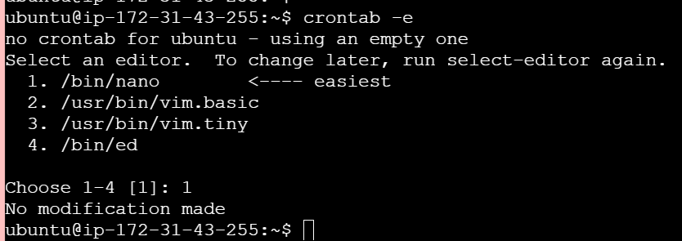
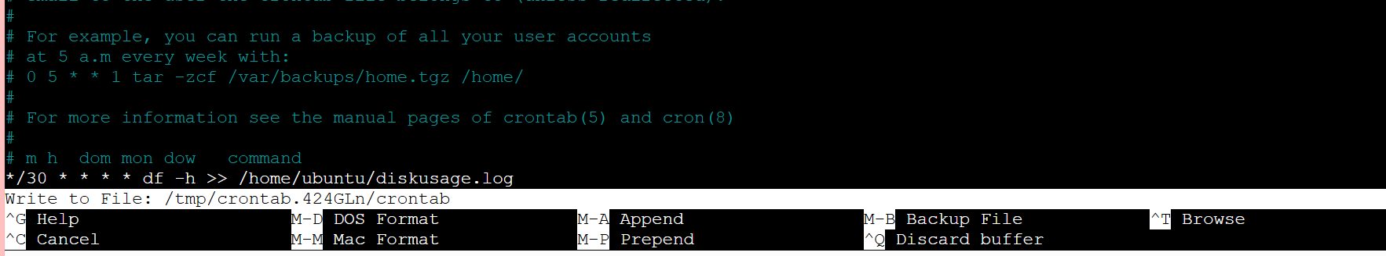
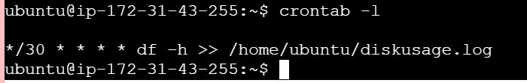
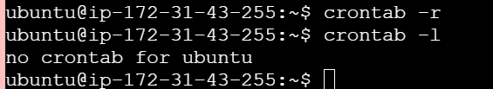
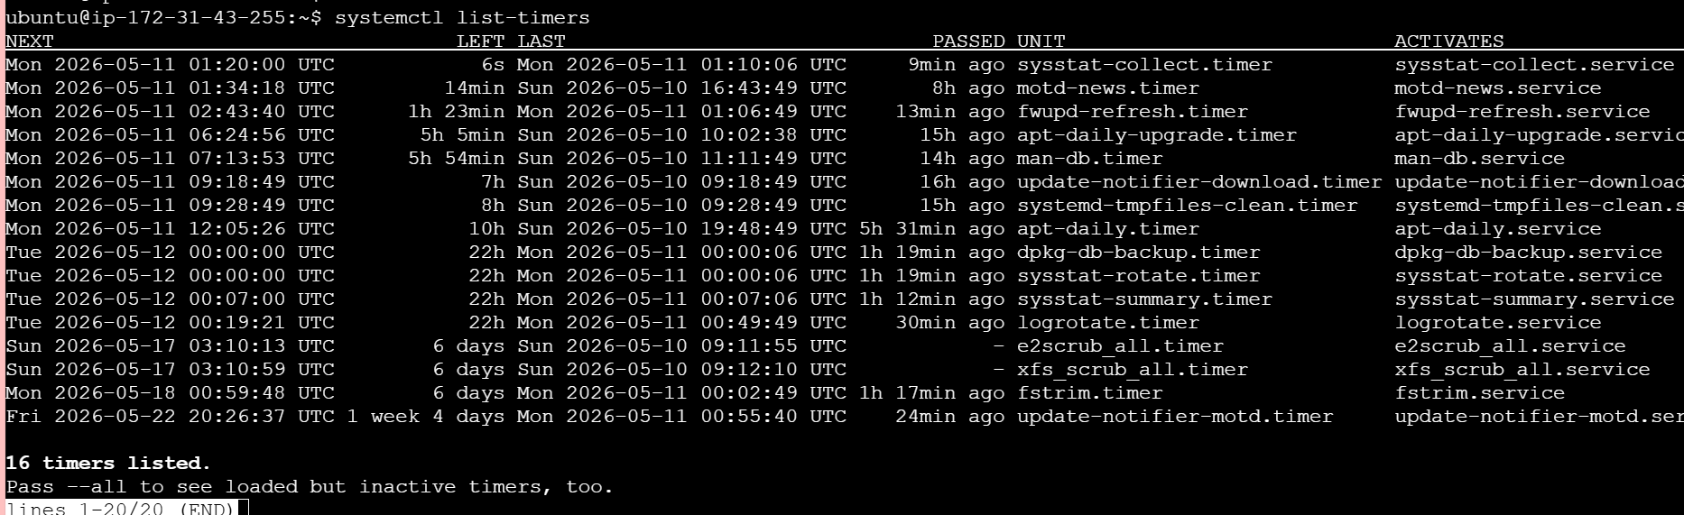
Process Management Commands
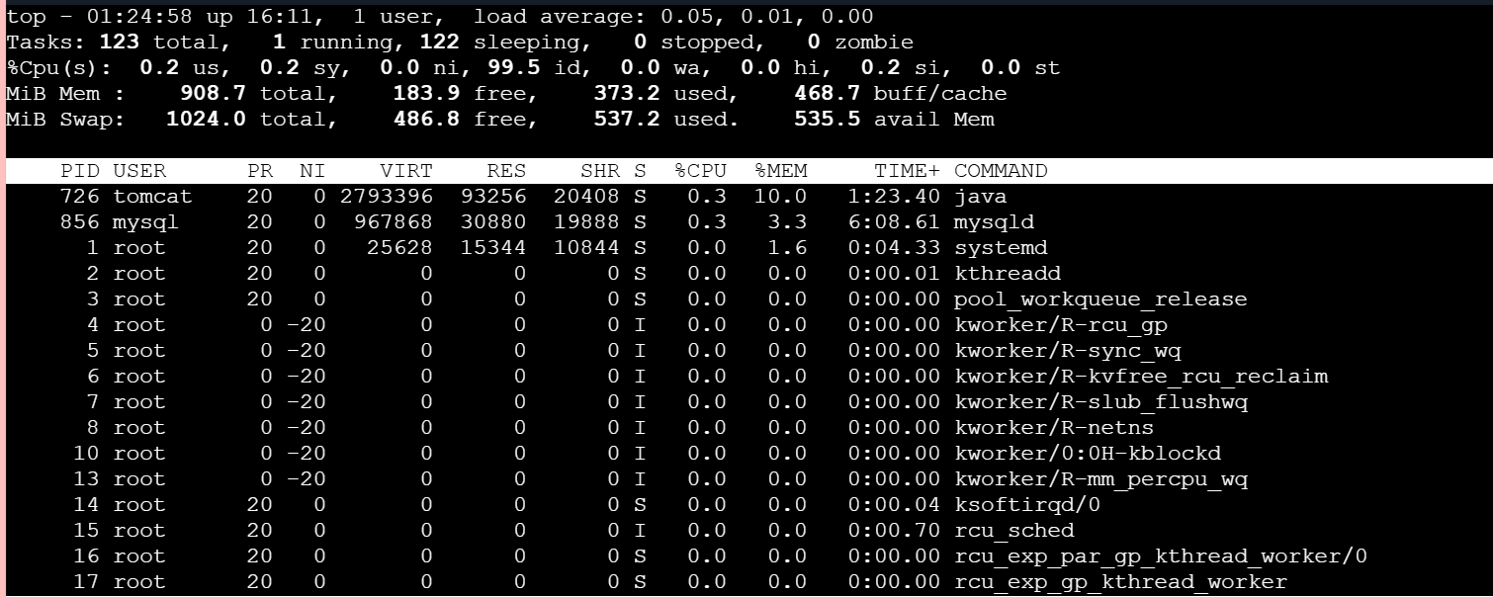
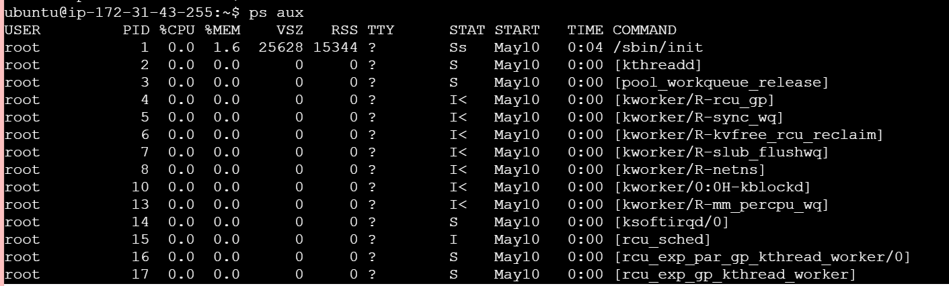
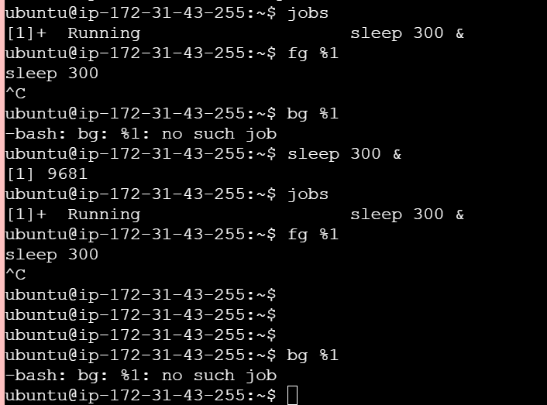
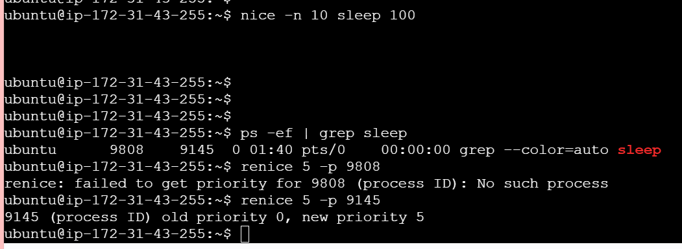
Managing Time commands

